The task lesson 1.1

Part 1

I have written 3 simple lines of code all indicating an action to write a statement on the website in 3 different ways.

First one being directly from The HTML file without incorporating JS, second one with JS from and HTML file and third being with JS from a js. Demonstration in the photos down below.

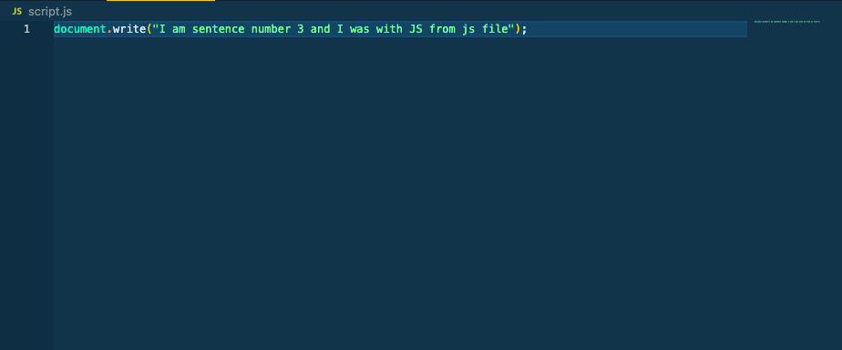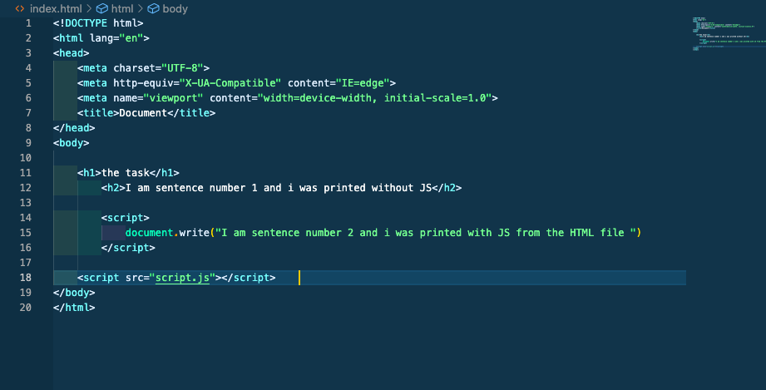

As you can see in the photo of the website itself the text order appears to be exactly in the same order that is written in HTML file.

I tested and found the sentences changed order when the line of code corresponding to the sentence moved up or down in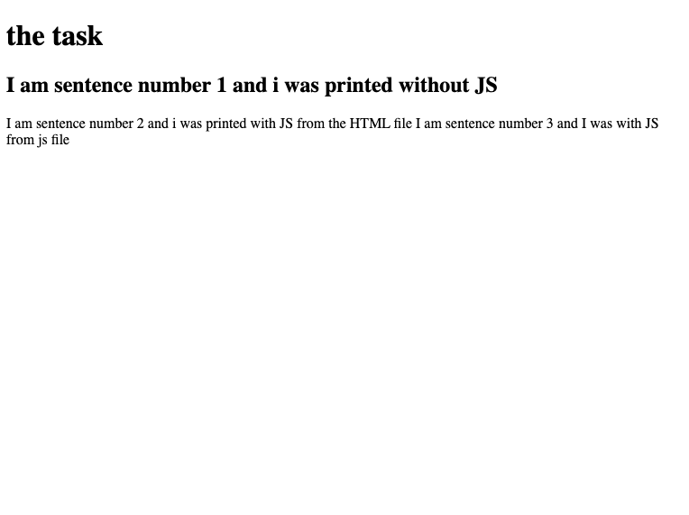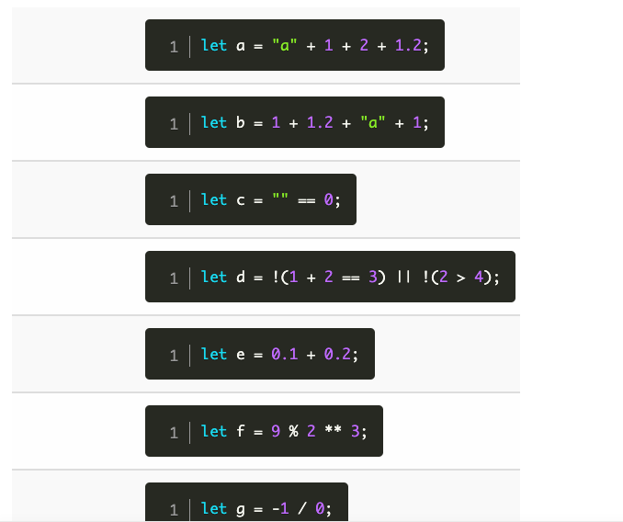part 2:

The answers in correct order:

a = a121.2

b = 2.2a1

c = false or NaN

d = true (2 is not bigger than 4)

e = false (0.1 + 0.2 comes out to 0.300000004)

f = 1

g = -1